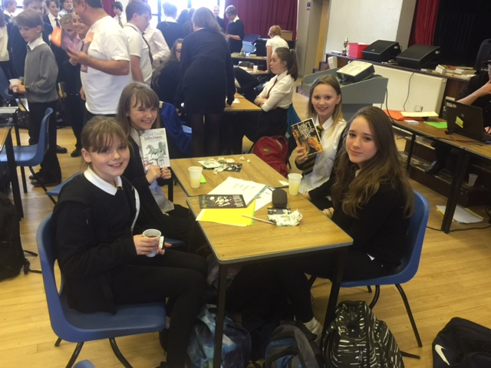
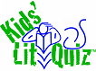 Kids’ Lit Quiz 2015

We are (Abby Pearson, Ava Moffat, Maya Pearson and Beth Falconer).We are a group of S1 pupils from Dalkieth High school who were chosen by our teachers to participate in the Kids’ Lit Quiz 2015!
There were ten rounds of ten questions with prizes to be won throughout.
Unfortunately we didn’t win but we tried our best and we had lots of fun!!
We enjoyed participating in this year’s competition and we hope we will be able to do it again next year.

Thanks again
Abby, Ava, Beth & Maya

