DO NOT ANSWER THIS QUESTION IF YOU HAVE ALREADY ANSWERED QUESTION 7

Question 8: Population

Map Q8 shows the main origins of USA immigrants .

  - Describe and suggest reasons for the patterns shown on Map Q8.

  - With reference to an international migration you have studied describe the impact on both the donor and receiving country.

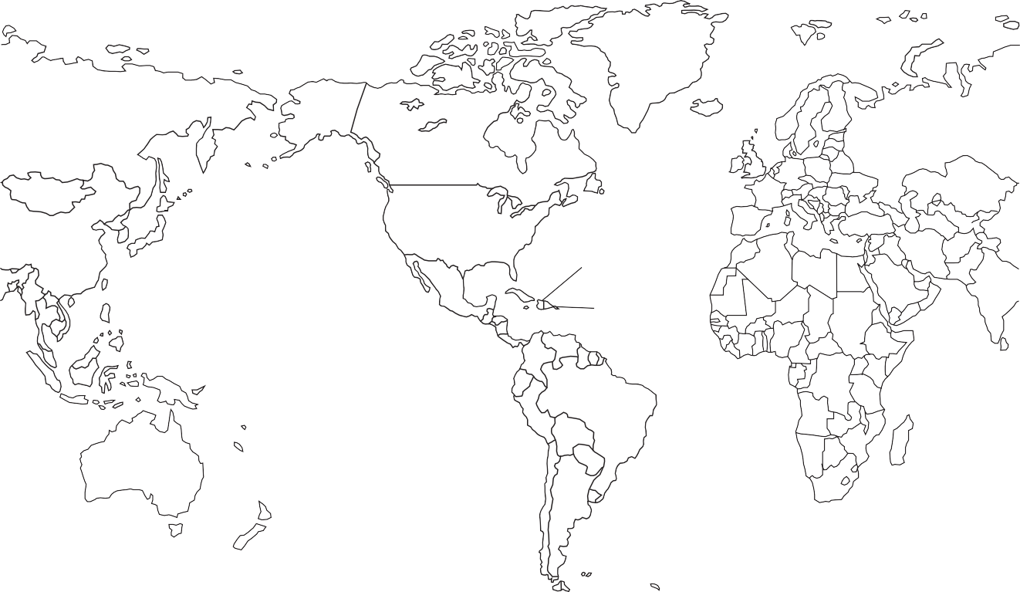Map Q8: Origin of immigrants into the USA (number in thousands)
South Korea 23
China 83
USA
Haiti 22
Philippines 55
Vietnam 33
Mexico 143
Cuba 36
Colombia 22
Dominican Republic 46
India 66

[END OF QUESTION PAPER]

