Senior Leadership Team Learning Walks May 2018
The focus of the Learning Walks was sharing classroom experiences and this directly links to the revised DHS Learning, Teaching and Assessment policy.

In light of feedback from the inspection, it is important that the school moves towards a more formalised format when sharing classroom experiences. SLT used a new Learning Walk document to help gather information based on our agreed 'non-negotiables' and this was also used to provide high quality feedback to individual staff. This document was created using the revised Learning and Teaching policy, focusing mainly on the ‘non-negotiables’, and a number of PT(C)s stated that they will use this document during their departmental observations for moderation purposes.

Members of SLT spent approximately 25 minutes in a classroom and started at either the beginning or half way through the lesson. As always, the focus was on the learning experiences of the young people and staff were assured that SLT would be talking to them about their learning as and when this was appropriate in the classroom context.

Each of the five members of the Senior Leadership Team selected two periods during the week beginning the 21st May 2018 in which they would complete Learning Walks.
Once these two periods were identified, they were then allocated two different classes to visit during each of the periods. They were asked to, as appropriate, speak with or observe several learners in each of these lessons to gain an understanding of the learning taking place in the classroom. Therefore, SLT aimed to gain ‘snapshots’ of learners’ experiences in around 18 - 20 different lessons.
Classes were allocated to try to ensure as even a spread as possible across the school and feedback from staff, following the last Learning Walks, indicated that they would prefer to know when SLT would be in the classroom. Therefore, a mixture of classroom teachers and PT(C)s that weren’t involved in the last round of Learning Walks in March were selected and notified accordingly. This structured approach was important as it meant that staff felt more prepared and less anxious about these walks. The school is gradually moving towards creating a culture where a member of the Senior Leadership Team could walk into a classroom to simply experience the learning taking place in a range of different classes. This culture will undoubtedly help the school in its journey towards excellence and promote consistency in terms of learning and teaching, in particular the ‘non-negotiables’. The Learning Walk documents are designed to support the classroom teacher and promote reflective practice across the school. Following on from feedback during an ELT meeting, the Learning Walk documents were developed to acknowledge good practice as well as strengths and areas for development.
Following on from feedback after the first round Learning Walks, the Learning Walk document was created and developed to enable SLT members to give staff high quality individualistic feedback.
The discussions undertaken with pupils and/ or staff varied according to their year group and the context of their learning during the Learning Walk.
SLT visited the following subjects: Business Education (1), English (3), History (1), Horticulture (1), Modern Studies (1), Music (2), PE (1), PSE (1), Science (2) and Modern Languages (1)
The comments below were collated during the Learning Walks. Some are in the words of the learners themselves and others are observations made by the visitors.
Before the lesson
- Good humour was mixed with a firm approach to settling the class to allow the learning to begin. (English)
- Very warm welcome given to pupils by teacher. Good classroom routines used to settle the class quickly. (PSE)
- Very explicit instructions given to create clear expectations at the very beginning of the lesson. (Music)
- Learners in seats promptly and ready to learn. The teacher was very efficient at the beginning of the lesson and set a good pace from the moment they entered the classroom. (History)
- Learners were met by teacher as they walked into the department and clear instructions were provided to ensure they were efficient when changing. An effective routine has clearly been established and pupils were fully aware of the department’s expectations. (PE)

During the lesson
- Very good questioning techniques – a real strength that should be shared as good practice (Science)
- Excellent checking for understanding in plenary through the use of traffic light coloured cards (Science)
- Active learning/collaborative task leading to full engagement in learning. (Business)
- Very creative lesson that engaged all learners and the focus of the lesson was to develop listening skills (English)
- Pupils worked collaboratively and were responsible for a specific section of their learning that took place over the year (Languages)
- All pupils stated that they were enjoying the experience and felt stimulated by the physical and mental challenges throughout this lesson (PE)
- The teacher was facilitating the lesson and learners were given opportunities to lead their own learning (PE)
- Classroom discussion and the teachers approach to questioning created a stimulating learning environment (History)
- Teacher identified that only some learners were contributing to class discussions which resulted in the teacher adapting their approach to questioning. This ensured that all learners were engaged and allowed the teacher to clarify that learning was taking place for the entire class and not just a select few. (History)
- Pupils were able to confidently demonstrate the progress they’ve made so far and successfully identify and justify their next steps (Music)
- Pupils were developing valuable skills, especially team work, and it was clear that the teacher was promoting the learners to take more responsibility and lead their own learning (Horticulture)
- Learning intentions were very clear with explicit references to skills with a real focus on evaluating. (Modern Studies)
- Teacher has created a very stimulating learning environment by introducing a really interesting topic for discussion and creating an inclusive atmosphere whereby everyone was involved. (Science)
- Very explicit instructions were given to pupils as they entered the classroom and the teachers expectations were immediately clear for all learners. (Music)
- The teacher clearly linked the success criteria to the learner qualities and there was an emphasis on resilience which was identified by the learners. (Music)
- There was a lot of conversation around thinking and learning which allowed pupils to reflect on their progress throughout the lesson (Music)
- A good collaborative task was used during the lesson and allowed the pupils to lead their own learning throughout this part of the lesson (PSE)

Towards the end
- Good use of praise was used during the plenary to encourage participation (Science)
- The lesson was successfully brought to a close through the use of a good plenary activity that encouraged the learners to reflect on the learning intentions and success criteria. (Languages)
- Next steps were identified by the pupils and the teacher had clearly established a strong routine for tidying up at the end as the learners knew their role and were very efficient (Horticulture)
- Pupils left the classroom in a very calm and orderly fashion. The teachers expectations were clear and an effective routine put in place (Science)
- Pupils were given the opportunity to reflect on their own learning during the plenary (English)

Learning Walks May 2018 – Staff Feedback

Learning Walk document
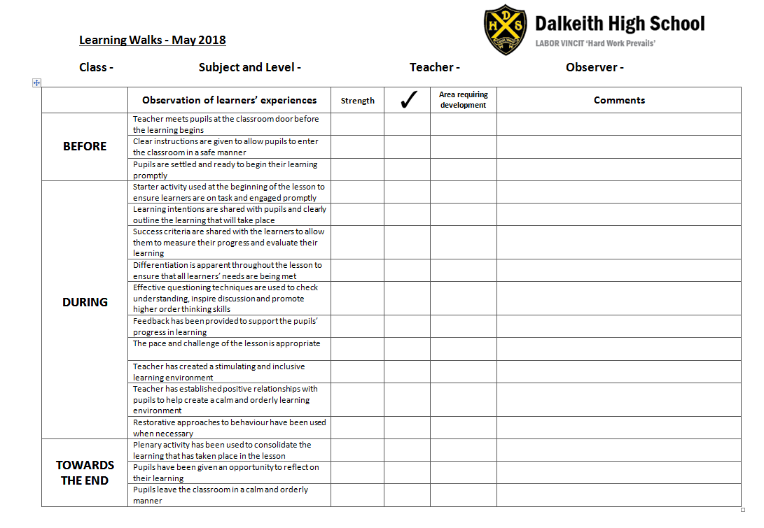
The learning walk document was developed following feedback from staff evaluations and ELT discussions. The introduction of an extra column ( ) between ‘Strength’ and ‘Area requiring development’ allowed good practice to be acknowledged without the restriction of being labeled as either a strength or an area requiring development. This allows more flexibility during the Learning Walk process and staff can clearly identify their next steps based on the information gathered within this document.

This new column has been added to the Learning Walk document to enable SLT to identify areas of good practice as well as strengths and areas requiring improvement.

Next steps
Learning Walks will be carried out in the new session (October) and the ‘non-negotiables’ from the revised DHS learning, teaching and assessment policy will continue to be an ongoing focus throughout the year.
Effective questioning has been identified as an area that requires improvement following the last two rounds of Learning Walks. There was evidence of strong practice in this area in a few classes observed during the Learning Walks and those specific staff will be given the opportunity to lead a whole school CAT session on developing questioning techniques in the new session.
As a school, we continue to work towards continuous improvement and ensuring consistency across the school, in terms of learning and teaching, is one of the main priorities in light of our recent inspection. The Learning Walks have allowed SLT to gauge where we are as a school in relation to this following the whole school review and HMIe inspection. Consistency of our ‘non-negotiables’ or key aspects of the revised learning and teaching policy can only be achieved by continuing to take a formalised approach to classroom observations and PT(C)s have already expressed an interest in using the Learning Walk observation paperwork for their own moderation purposes at departmental level. PT(C)s have also expressed an interest in being directly involved in the Learning Walks and this will be built into the final round of walks that will take place in May 2019.

