Newspaper Narrative Structures

In your jotter, make a list of each topic of story in the order that that occur:
Page 1 – Osama Bin Laden still alive
Immigrants are taking over the world

Page 2 – Standards are slipping with new curriculum
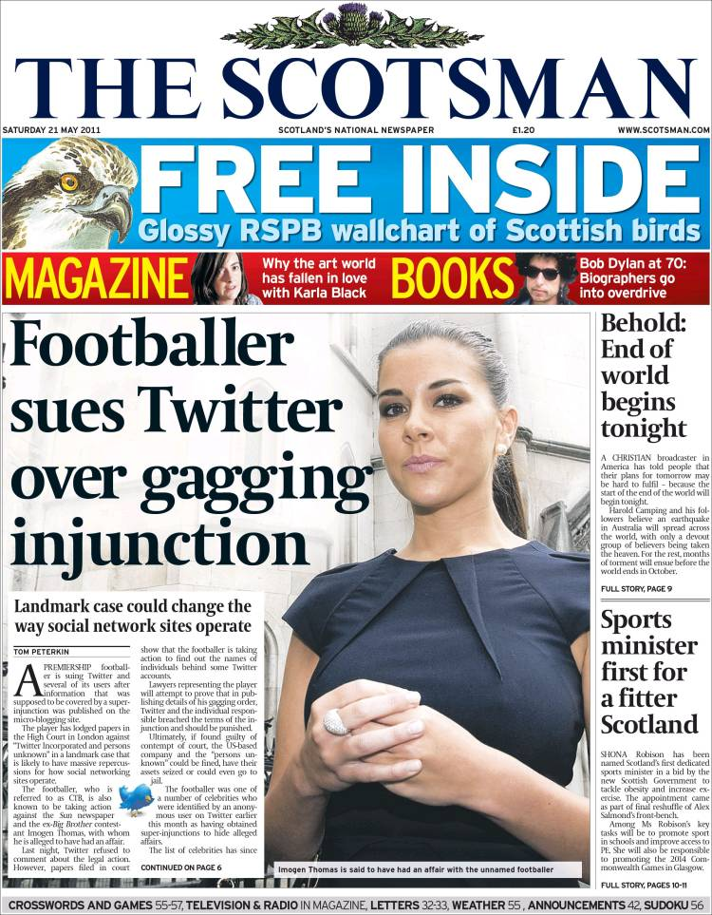
Etc.

Next you are going to choose four different colours to highlight the stories:
  - First colour for Politics/Finance/Business
  - Second colour for Sport
  - Third colour for Human Interest
  - Fourth colour for Entertainment
Now write down what pattern do you notice and explain why you think there is this pattern.

Next you need to:
  - Underline all the stories that are Local News
  - Circle all the stories that are National News
  - Leave blank all the stories that are World News
Now write down what pattern do you notice and explain why you think there is this pattern.
