Question 1: Lithosphere

Study Diagram Q1.

Select one erosional landform and one depositional landform from Diagram Q1. With the aid of annotated diagrams, explain the formation of each feature.

Diagram Q1: A Glaciated Landscape
Marks

14

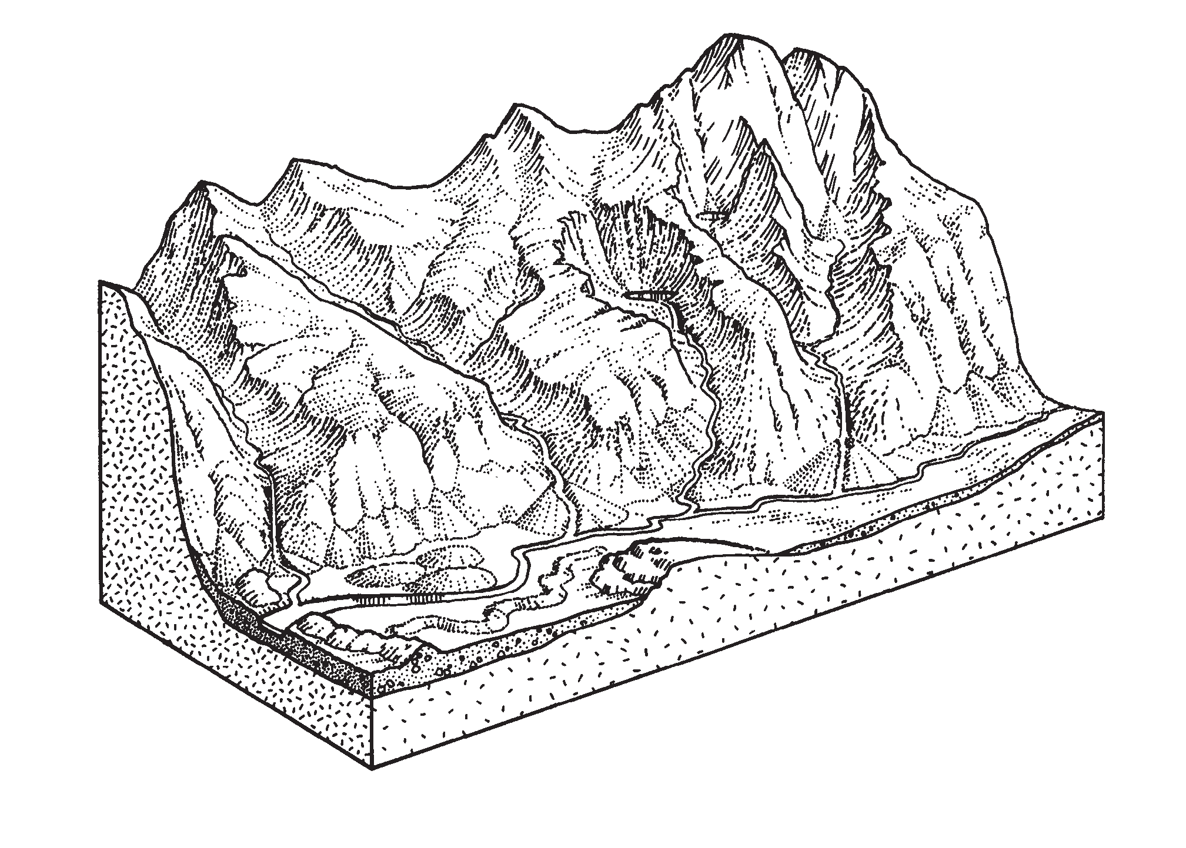corrie

arête

hanging valley
U-shaped valley

terminal moraine

esker

drumlins
roche mout

Question 2: Rural Land Resources

- Describe and explain, with the aid of annotated diagrams, the formation of the main features of glaciation in the Cairngorms National Park or any other glaciated upland area you have studied.

- Study Diagram 2..

With reference to the Cairngorms National Park or any other upland area you have studied, explain the social and economic opportunities created by the landscape.

- Referring to named examples within the Cairngorms or any other upland or coastal area you have studied:
  - describe and explain the environmental conflicts that have occurred;
  - describe the solutions to these environmental conflicts commenting on their effectiveness.

Diagram Q2: The Cairngorms Mountain Range
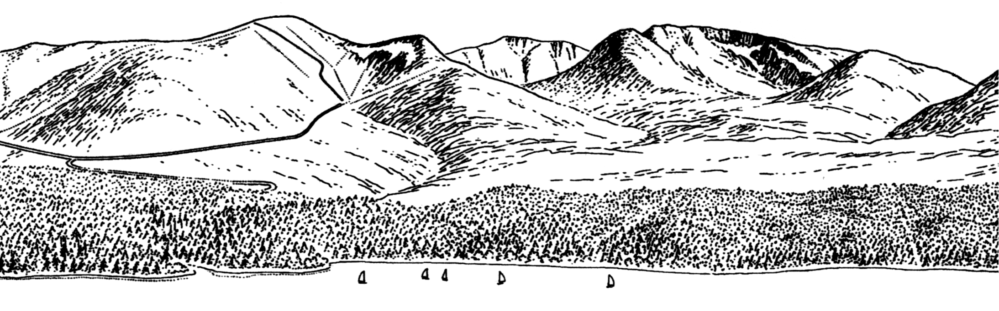
Marks

Cairngorm Ski slope

Loch

20

8

11

Question 3: Lithosphere

Study OS Map Extract number 1940/115: Snowdon (separate item), and Map Q3.

- Describe the evidence which shows that Area A, shown on Map Q3, has been affected by the processes of glacial erosion.
You should refer to specific named features and make use of grid references.

Map 3:: Snowdon

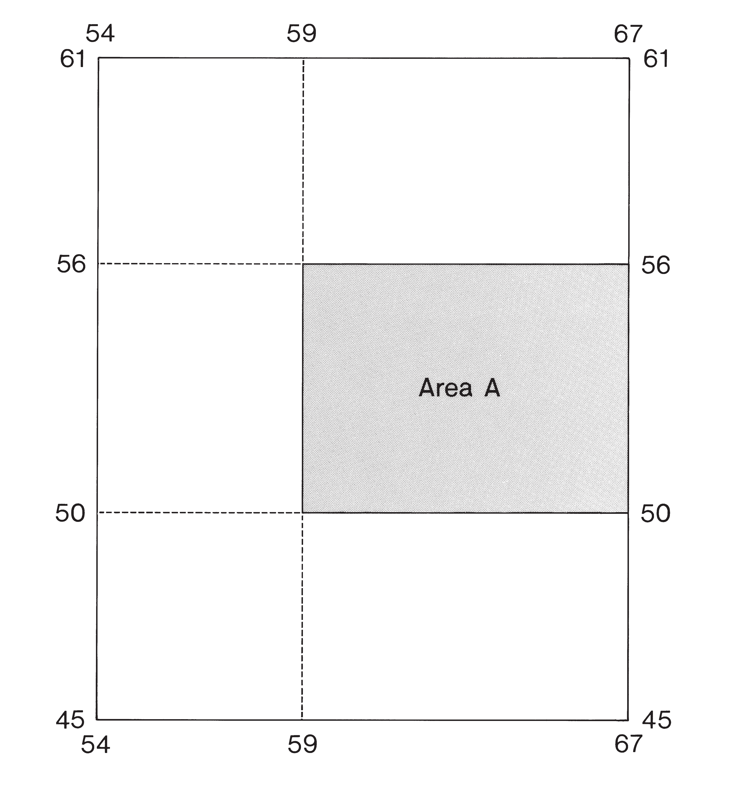
- Explain, with the aid of an annotated diagram or diagrams, how one of the following features of glacial deposition is formed:
  - terminal moraine
  - esker
  - drumlin.

Question 4 (Rural Land Resources)

- Study Map Q4A.

Describe and explain, with the aid of annotated diagrams, the formation of the main features of glacial erosion in the Lake District or any other glaciated upland area which you have studied.

- Study Diagram Q4.
With reference to the area around Coniston Valley, or any other upland area you have studied, explain the social and economic opportunities created by the landscape.

- Study Map Q4B.
The Lake District and Snowdonia are both areas of outstanding glaciated scenery.
Explain why these two National Parks attract widely differing numbers of visitors.

- For the Lake District or any other upland or coastal area you have studied:
  - explain the environmental conflicts that may occur due to an influx of visitors. (You should refer to specific named examples within your chosen area);
  - for one of the conflicts explained in part (i), describe the solutions to this conflict and comment on their effectiveness.

Map Q4A: The Lake District
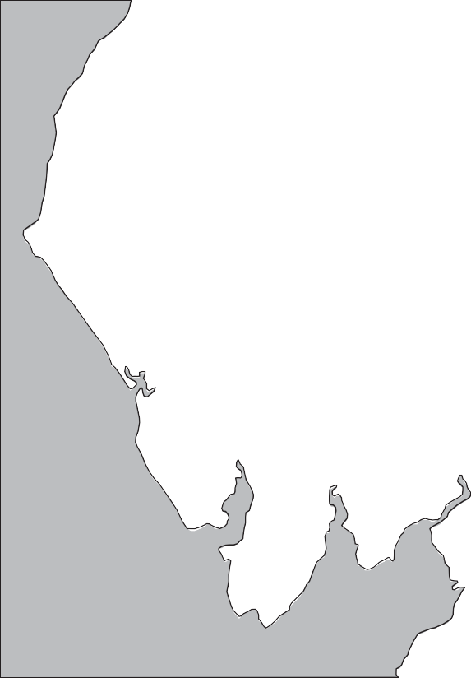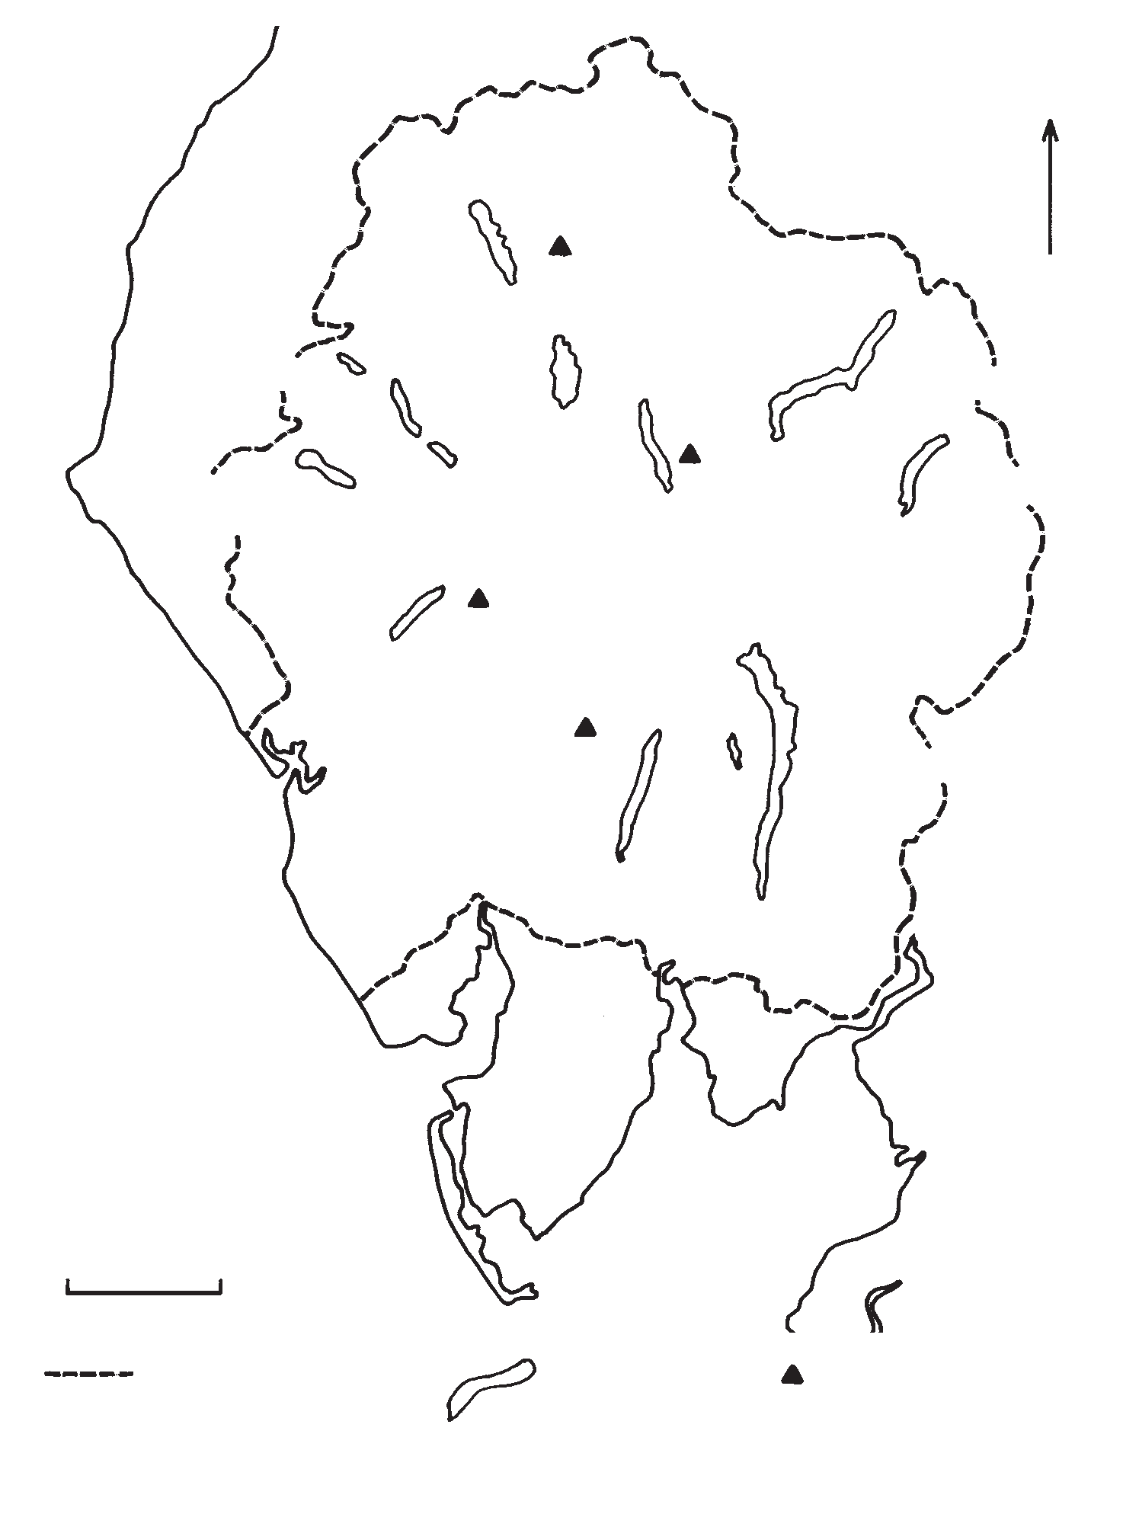
Marks
N
BASSENTHWAITE
Skiddaw 931
LOWESWATER
CRUMMOCK
WATER
DERWENT
WATER
ULLSWATER
ENNERDALE
WATER
BUTTERMERE
THIRLMERE
Helvellyn 949
HAWESWATER
WAST Scafell Pike
WATER
978

Old Man of Coniston 803
CONISTON WATER
WINDERMERE
0
10km
National
Park boundary
Major
lakes
Selected
mountain
peaks (height in
metres)

18

10

6

10

6
(50)

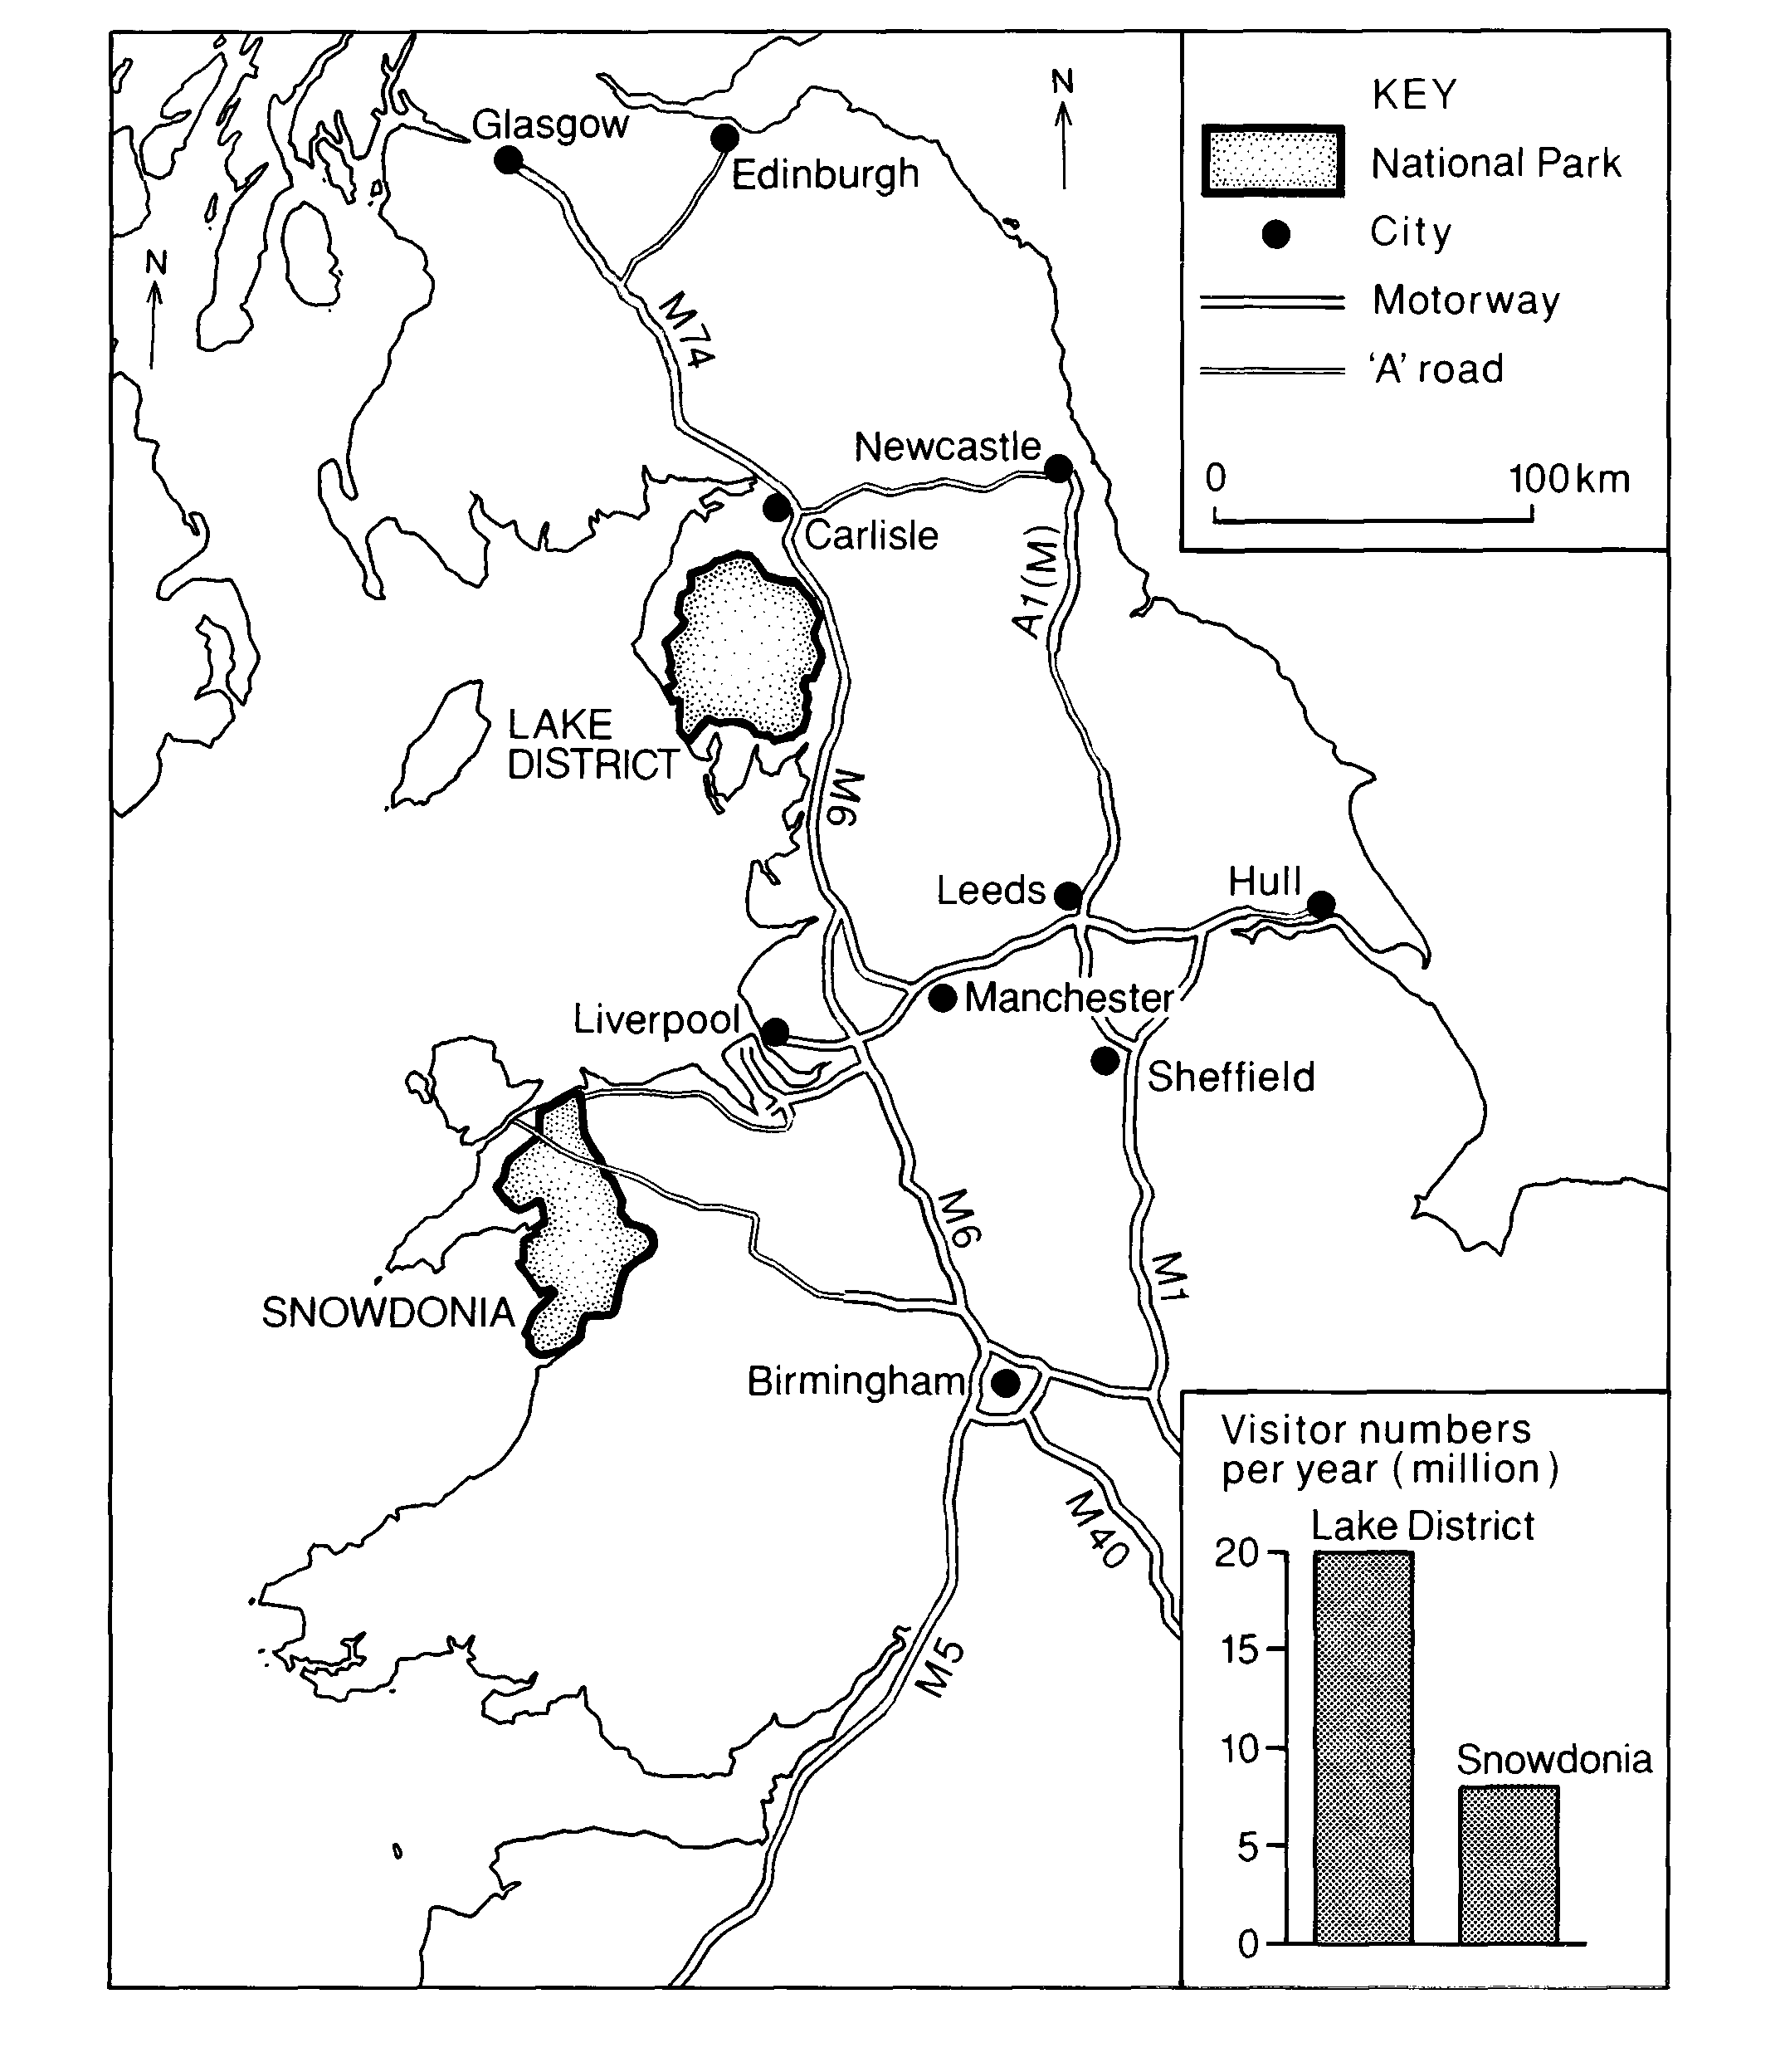
KEY
Glasgow
Edinburgh
National Park
City Motorway
M74
‘A’ road
Newcastle
0
100 km
Carlisle
LAKE
DISTRICT
M6
Leeds Hull
Liverpool
Manchester

Sheffield

M6
M1
SNOWDONIA
Birmingham
M40
Visitor days
per year (million)
Lake District
M5
Snowdonia

Map Q4B: Major Roads and Settlements around the Lake District and Snowdonia

Question 5: Lithosphere

Study Diagram Q5.

Scree is a feature of both glaciated and limestone upland landscapes.

- Describe and explain the conditions and processes which encourage the formation of scree slopes.

Corries are landscape features in glaciated upland areas.

- With the aid of annotated diagrams, explain the processes involved in the formation of a corrie.

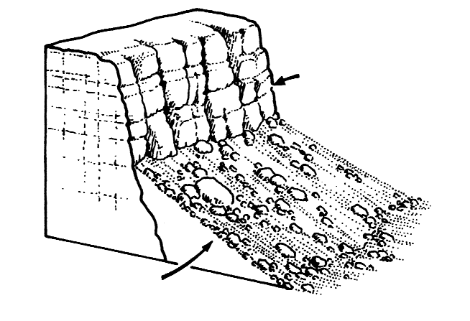 Diagrm Q5: Scree
Bare rock
Scree slope
Marks

7

9

