Institutions – Internal Controls
Ownership

Who owns the text can have a direct impact on the creation of the text itself. This will mean you will have to know the companies and people involved. To do this you should consider the following:
- The size of the company
- The country they are based or were founded
- The political bias of the company
- The previous output of the company
- Their reputation
- Their field of expertise
- Their current level of influence
- Any significant history
Let’s take an example from the world of feature film. There is a collection of companies in Hollywood known as ‘The Big Six’, which includes 20th Century Fox, Paramount, Warner Bros., Columbia, Universal and Walt Disney Studios. If we look at one of those companies we can get an idea of why knowing about the company can tell us a lot about the text.
The ‘Walt Disney Motion Pictures Group Inc.’ actually includes:
- Walt Disney Pictures
- Walt Disney Animation Studios (DisneyToon Studios)
- Pixar Animation Studios
- Disneynature
- Marvel Studios
- Lucasfilm
The Walt Disney Company was founded in 1923 by Walt and Roy O. Disney, and they are based in California, USA.
Previously produced films (ranked by domestic gross)
1 The Avengers 2012
2 Pirates of the Caribbean: Dead Man's Chest 2006
3 The Lion King 1994
4 Toy Story 3 2010
5 Iron Man 3 2013
6 Frozen 2013
7 Finding Nemo 2003
8 Alice in Wonderland 2010
9 Guardians of the Galaxy 2014
10 Pirates of the Caribbean: At World's End 2007
Recent notable events include:
- On January 23, 2006, it was announced that Disney would purchase Pixar in an all-stock transaction worth $7.4 billion.From this Steve Jobs, became Disney's largest individual shareholder at 7% and a member of Disney's Board of Directors. Ed Catmull took over as President of Pixar Animation Studios. Former Executive Vice-President of Pixar, John Lasseter, became Chief Creative Officer of Walt Disney Animation Studios, its division DisneyToon Studios, and Pixar Animation Studios, as well assuming the role of Principal Creative Advisor at Walt Disney Imagineering.

- On August 31, 2009, Disney announced a deal to acquire Marvel Entertainment, Inc. for $4.24 billion. The deal was finalized on December 31, 2009 in which Disney acquired full ownership on the company.

- On December 21, 2012, Disney completed a deal to acquire Lucasfilm with the acquisition value amounting to approximately $4.06 billion, and thus Lucasfilm became a wholly owned subsidiary of Disney.
- On December 9, 2014, dozens of companies including Microsoft, Disney and Koch Industries were dragged into the Luxembourg tax avoidance “LuxLeaks” scandal with the release of new documents by investigative journalists. The new claims emerge from 28,000 pages of documents obtained by the International Consortium of Investigative Journalists (ICIJ), and examined by dozens of newspapers.
Task
Based on the above information answer the following questions, ensuring that you give a reason for your answer.
- Is Disney well known in the US?
- Is Disney well known in the rest of the world?
- Who is the target audience for the majority of Disney’s film output?
- Who is less likely to go see a Disney film?
- Name three things you would expect from a Disney hero(ine).
- Name three things you would expect from a Disney storyline.
- Why do you think that Disney announce release dates with unconfirmed titles?
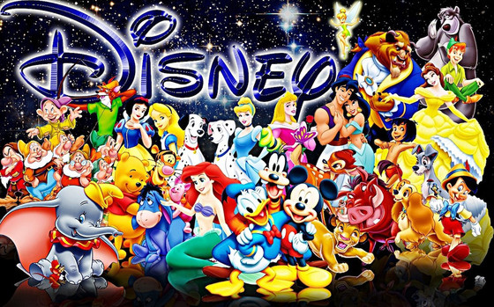
- List five things you would never expect to see in a Disney film (give a reason for each thing).

