S6 Careers
Newsletter
Dalkeith High 2021/22
Since this is your last year at school, it’s essential to begin now to think about what you are going to do in the future. If you are planning to apply for university, you’ll need to make your choice of courses and complete your application before the end of November. If you’re going to apply for college or for jobs, applications should be made early in 2021. The information below gives you advice on how you can make well informed career choices.

My World of Work – www.myworldofwork.co.uk
Skills Development Scotland’s careers website My World of Work is designed to help you develop your Career Management Skills.
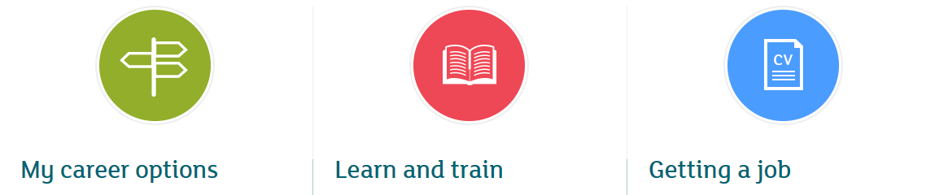

In the My Career Options section you can use the tools below to identify jobs which match your Self and Strengths and Skills. If you already have a job in mind, select Ambition to find out the routes into your chosen career. You can also include information on your qualifications in the Education section and your work Experience to find jobs which might suit you.

The Learn and Train section helps you explore your Horizons with information on courses at college and university, including guidance on the UCAS application, as well as other giving you details of other options such as volunteering, work based learning and taking a gap year.

Once you know what you’d like to do, how can you get that job? What resources and Networks can help you? Use the Getting a Job section for information on job search and making applications, including advice on writing a job winning CV and going for interviews. You can also search for current job vacancies, including Modern Apprenticeships.

Higher Education
If you are planning to apply to university, you will be given information and advice in school on how to make your on-line application using the UCAS website. You can also use this website to do an initial search for information on courses. Look too at university prospectuses, which you can order on-line, and at universities’ own websites for more detailed information on courses and university life in general.

However, the best way to find out about universities is to go along to see them yourself, so try to attend Open Days at any universities whose courses you are considering. You usually need to book in advance to attend an open day. Look at the list of Higher Education Open Days 2021 (available in the school library or look in the Higher Education 2021 section of www.edubuzz.org/midandeastvacancies website) for dates and booking arrangements. Many open days are held on school days, Monday to Friday. However, some universities hold their Open Days on Saturdays, which will hopefully allow you to go to all the institutions you want to visit.

For some courses relevant work experience is essential. If you haven’t managed to arrange this already, do so as soon as possible, so that you can refer to it in your application.

Make realistic decisions about course choice. The entry requirements shown in prospectuses and on websites are those which universities expect you to have gained in S5. If you don’t already have these qualifications, but are taking Highers over two sittings, fifth and sixth year, you will be asked for additional subjects at Higher, or a higher grade of pass or possibly both. Apply for a college course, eg HNC/D, as a backup, if you feel that you might struggle to achieve the grades needed for university. You can use your HNC/D qualification as a stepping stone on to a degree.
Graduate Level Apprenticeships
Did you know 72% of Scottish employers think job applicants lack technical, practical or job specific skills?
A Graduate Apprenticeship helps you build the skills and knowledge that Scottish industries need. You'll work, get paid, and achieve a degree. You'll spend most of your time learning on the job, but will also be a student at a university or college.
- You'll be in a paid job
- You'll gain your qualification with a respected university or college. There are 12 courses on offer, across four subject areas at many universities and colleges with more coming on board over the coming year
- Instead of thinking about how things might happen in the real world, you'll be putting your learning into practice right away. You'll solve problems on real projects
- The work you do counts towards gaining your qualification – meaning you could gain your degree faster
- GAs are designed by industry and for industry – so you can be confident that what you learn is relevant, and right for the role you're in

Going to College
Applications, for courses beginning at Edinburgh College in August 2022, will open at the beginning of January 2022. Watch out for a closing date and courses will close once they have reached a maximum number of applications. It’s, therefore, essential to apply as early as possible, so that you don’t miss out on being considered for a place.
College applicants may be interviewed and it’s important to be able to show, at interview, that you have an understanding of the type of work to which the course you are applying can lead. Related work experience can help with this.

Finding a job or a training place
Begin looking for work from November onwards. Use recruitment sites such as www.myjobscotland.gov.uk, www.apprenticeshipsinscotland.com, www.apprenticeships.scot, www.theguarantee.org and the Job Centre website www.direct.gov.uk as well as company and recruitment websites.
Skills Development Scotland has a local job vacancy website www.edubuzz.org/midandeastvacancies which pulls together information on job vacancies for school leavers in Edinburgh and the Lothians. The site also has links to training providers, information on voluntary work, links to company websites and other recruitment websites.
Many jobs are not advertised, so you may need to make speculative enquiries to employers, to ask about job vacancies. Send them your CV with a covering letter explaining what type of work interests you. Use the Business Directory on Midlothian Council’s website, www.midlothian.gov.uk, as a starting point to identify local employers to contact to ask about possible job opportunities. You may also hear about jobs from friends and family. Let them know what type of work you are looking for, so they can alert you to vacancies.

Careers Resources
As well as using My World of Work, you can also look at the following websites to do your own research into jobs and courses.

- Edinburgh College – www.edinburghcollege.ac.uk for information on local college courses
- Modern or Graduate Apprenticeships – www.apprenticeships.scot for details of MA /GA opportunities
- Scotland’s Rural College – www.sruc.ac.uk for information on courses in land-based industries
- Borders College – www.borderscollege.ac.uk for information on courses available in Galashiels
- Newbattle Abbey College – www.newbattleabbeycollege.ac.uk for information on courses
- Planitplus - www.planitplus.net for careers and course information
- UCAS - www.ucas.com for information on university courses
- Prospects – www.prospects.ac.uk for information on career opportunities for graduates
- Vacancies – www.edubuzz.org/midandeastvacancies information, vacancies and resources for North Berwick High students

Help from Skills Development Scotland
If you have researched information, but are still undecided about what to do, speak to your Pupil Support Leader to arrange a careers interview in school. Even if you don’t ask for an interview, I may speak to you to check on your plans or your Pupil Support Leader may refer you to us if they feel it would be helpful for you to have an interview.

You can also contact me in school or at the Skills Development Scotland Centre in Dalkeith by phone or email.
Barbara Moir 07787 831027, Barbara.moir@sds.co.uk

